Project Enhancements Guide

Contents

What is Odoo Project? 2

What is Odoo Project Enhancements? 2

Administrator Configuration 2

Task Logs (Timesheets) 2

Enabling Time Logs for Tasks 2

Forecasting 3

Enabling Forecasting 3

Forecast Settings 3

Sub-Tasks 3

Enabling Sub-Tasks 3

Project Statuses 4

Creating/Editing Project Statuses 4

Use Rating on Project 4

Collaborative Pads 5

Creating a new project (Not from Template) 5

Manage your project's stages 6

Add your project's stages 6

Rearrange stages 7

Creating a Task 8

Responsibilities 8

Followers 8

Project: follow a project to follow the pipe 8

Task: follow a specific task 8

Choose which action to follow 8

Auto Forecasting 9

Enabling Auto Forecasting 9

Viewing Forecasts 10

On Projects 10

On Tasks 10

Milestones 10

Enabling Milestones on a Project 10

Creating Milestones 11

View by Milestones 12

Scrum 13

Templates 13

Creating a Project Template 13

Create a new project (from Template) 13

Date Shifting 13

# What is Odoo Project?

Odoo Project allows you to manage a project together with your whole team, and to communicate with any member for each project and task.

# What is Odoo Project Enhancements?

Odoo Project Enhancements expands the Odoo Project App and adds new enhancements including Project Templates, Milestones, Scrum and Auto Forecasting options.

# Administrator Configuration

Some configurations are global settings, meaning they will affect all Projects. It’s important to set these global settings before creating Projects or using the Project Enhancements App. Each Project has their own settings that apply to the individual Project.

## Task Logs (Timesheets)

Task Logs allow for time management for Project Tasks. It adds a new tab on the Task form and allows users to enter Time Entries. Time Entries can then be used for billing purposes and allow for Forecasting to be used.

### Enabling Time Logs for Tasks

Enabling Time Logs enables will provide the option to use Timesheets on each Project. Only Admins can change this Global setting but once enabled, Project Managers can enable Timesheets on each Project independently.

1. Go to **Configuration/Settings.**

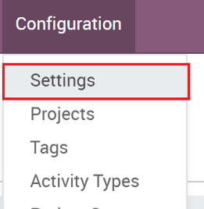

1. The ‘App Settings’ and it should auto select ‘Project’ on the left. Check the ‘**Task Logs**’ checkbox and click **Save.**

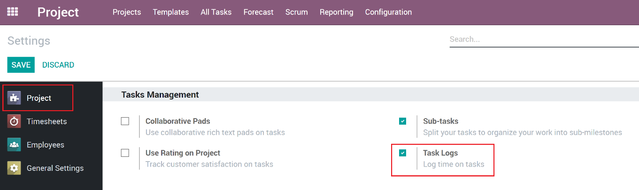

## Forecasting

Scheduling and forecasting tasks is another way to manage projects. In Odoo, the Forecast option gives you access to the Gantt chart. With the Forecast option, you can schedule/forecast other users who will be working your project tasks and the Gantt view gives you the big picture. It's highly visual which is a real plus for complex projects, and it helps team members to collaborate better

### Enabling Forecasting

Enabling Forecasts enables will provide the option to use Forecasts on each Project. Only Admins can change this Global setting but once enabled, Project Managers can enable Forecasts on each Project independently.

1. Go to **Configuration/Settings.**

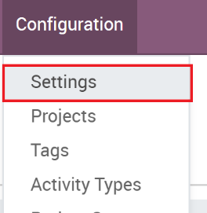

1. The ‘App Settings’ and it should auto select ‘Project’ on the left. Check the ‘**Forecasts**’ Box

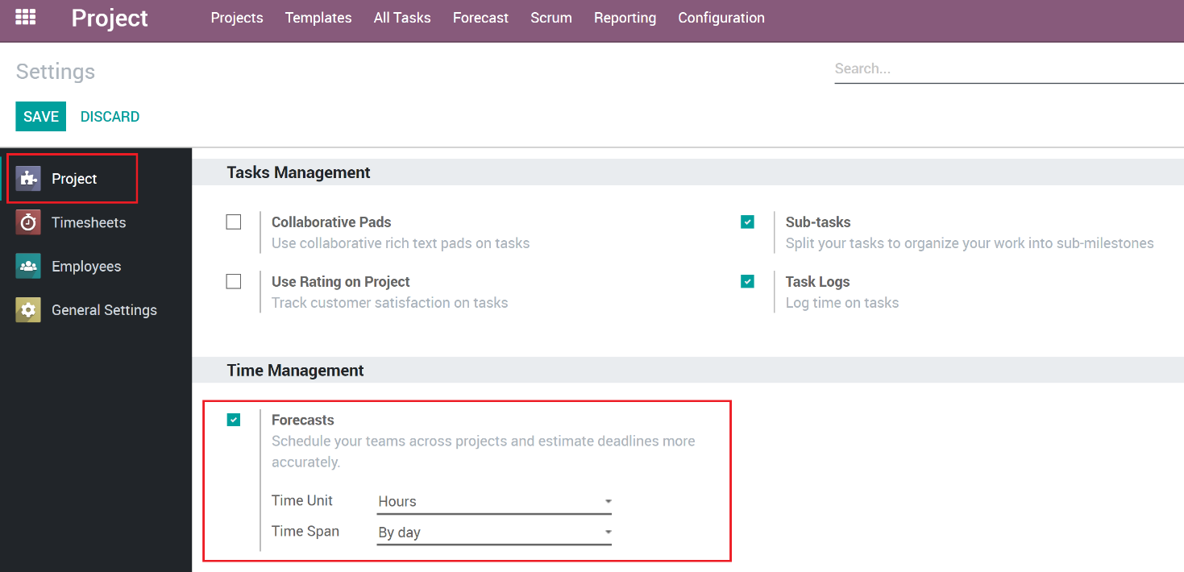

### Forecast Settings

Some additional settings are available once you enable Forecasts:

**Time Units (hours, days):** Specifies what time units will be used when creating Forecasts.

**Time Span (by day, by week, by year):** Specifies what time span will be used when looking at Forecasts on the Gantt Chart.

## Sub-Tasks

Sub-Tasks provide a way to link smaller Tasks to a parent Task. Enabling Sub-Tasks will add the ability to create sub-tasks on another Task. These Sub-Tasks are the same as a Project Task but will have a Parent Task assigned.

### Enabling Sub-Tasks

1. Go to **Configuration/Settings.**



1. The ‘App Settings’ and it should auto select ‘Project’ on the left. Check the ‘**Sub-Tasks**’ checkbox and click **Save.**

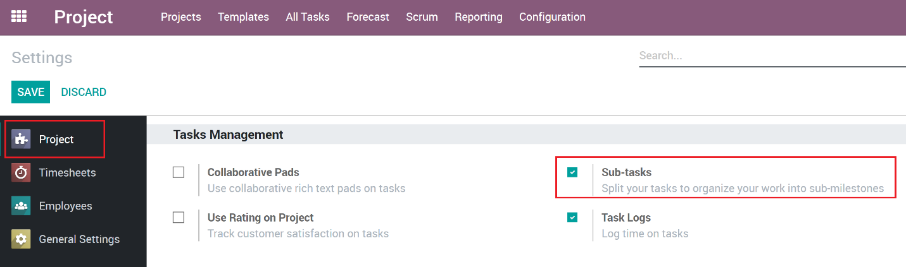

## Project Statuses

Project Statuses gives the users the ability to set and organize Project to defined statuses. Some sample statuses could be ‘Pending’, ‘In Progress’ and ‘Complete’. Project Statuses are a global configuration meaning all Projects will use the defined statuses. Note that each Project will have its own Task Statuses.

### Creating/Editing Project Statuses

Project Statuses are configured using the Configuration Menu.

1. Go to **Configuration/Statuses**

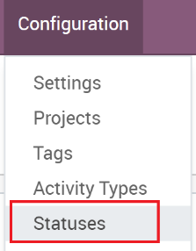

1. Click the ‘Create’ button to create a new Status

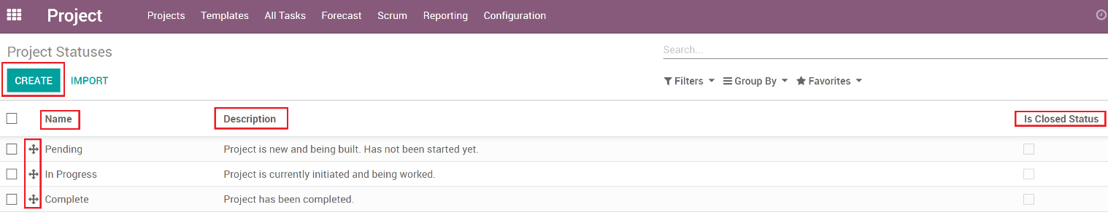

1. Enter a proper name and use the description field to provide the users an explanation for the usage of each status.
2. To re-order the list of statuses, enter debug mode and then you can drag the items in the list to re-order them.
3. Some filters use the ‘Is Closed Status’ field to no show Projects that are in a closed status. This is useful for a ‘Completed’ or ‘Canceled’ status.

## Use Rating on Project

More information needed!!!

## Collaborative Pads

More information needed!!!

# Creating a new project (Not from Template)

You can create a project from scratch by following this procedure. See “Create a new project (from Template)” to create a Project from an existing Template.

1. Open the Project application and click on **Create**.

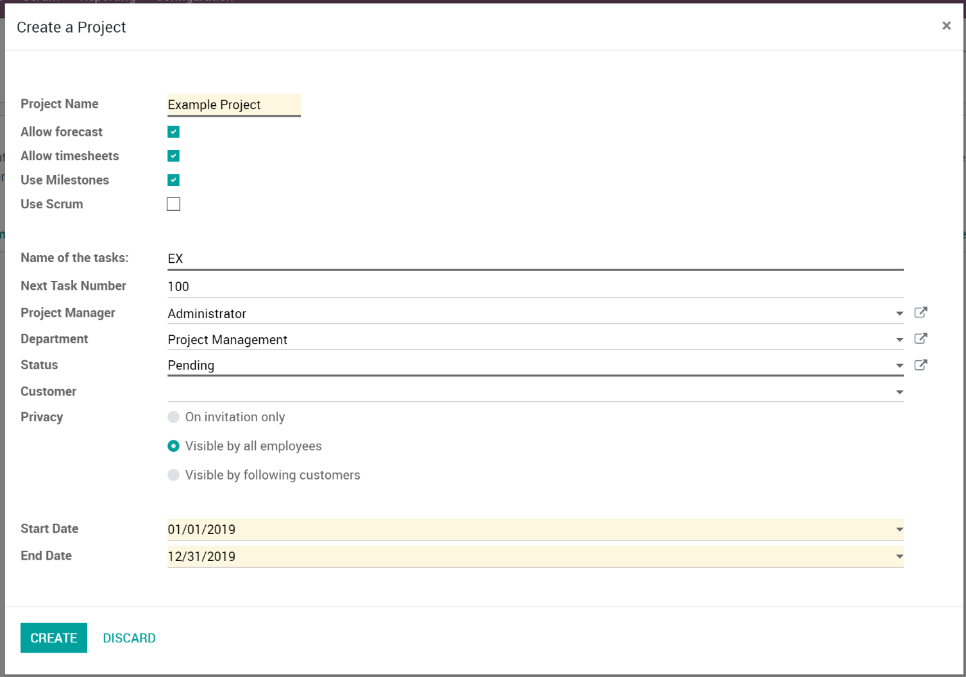

1. Field descriptions:
   1. **Project Name**: Specify the name of the Project.
   2. **Allow forecast**: Enables Forecasts for the Project.
   3. **Allow timesheets**: Enables Time Tracking for each Task on the Project.
   4. **Use Milestones**: Enables Milestones for the Project. See ‘Using Milestones’ for more information.
   5. **Use Scrum**: Enables Scrum for the Project. See ‘Using Scrum’ for more information.
   6. **Name of the Tasks**: Each Project will have its own Task labels that combine this field and the Next Task Number.
      1. For example, if you set this to PAV, and set the Next Task Number to 100, the next Task that will be created will have a Task Number of PAV-100 and will increment for each task created.
      2. Changing this later will change the labels of all Tasks associated with the Project.
   7. **Next Task Number**: Each Project tracks its own Task Numbers and you specify the next number here.
   8. **Project Manager**: The user who is managing the Project.
   9. **Department**: The Department that the Project is owned by.
   10. **Status**: The initial status for the Project.
   11. **Customer**: The customer that the Project is related to.
   12. **Privacy**: Who is given access to view/work the Project.
       1. **On invitation only**: Project is not visible to anyone unless they have been added as a follower.
       2. **Visible by all employees**: Project is only visible to employees and will see all tasks or issues.
       3. **Visible by following customers**: Project is visible by followers as well as following customers through Odoo’s customer portal, if the customer has been given the permissions to see their own portal pages.
   13. **Start Date:** The starting date of the Project.
   14. **End Date:** When the Project is set to be fully completed.
2. When you have entered all the required details, click on **Save**.

# Manage your project's stages

## Add your project's stages

1. After creating a new Project, it should take you directly to the Tasks.
2. In the new window, add a new column and name it according to the first stage of your project, then add as many columns as there are stages in your project.

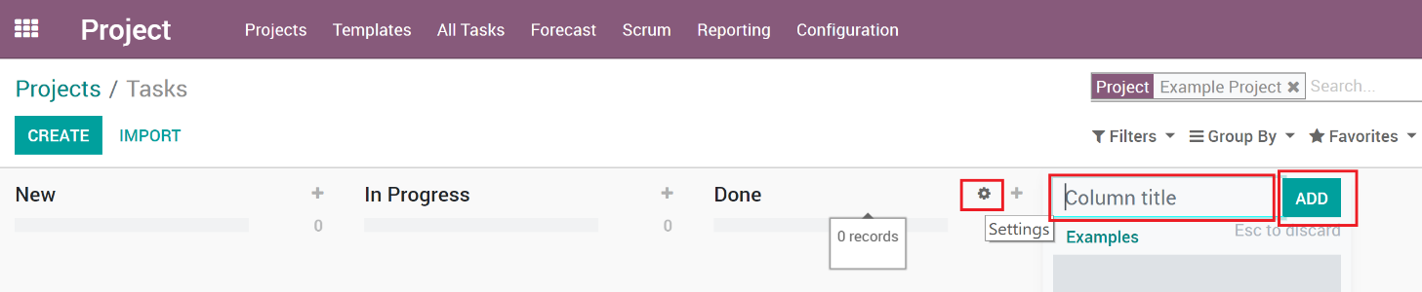

1. For each stage, there are markers for the status of tasks within a stage, that you can personalize to fit your needs.
2. Drag your mouse pointer over a stage name, and click on the appearing bearing, and on the opening menu, click on Edit.

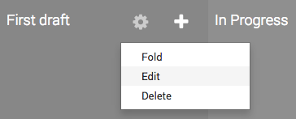

1. A new window will open. The color dots and star icon correspond to customizable markers applied on tasks, making it easier to know what task requires attention. You can give them any signification you like.

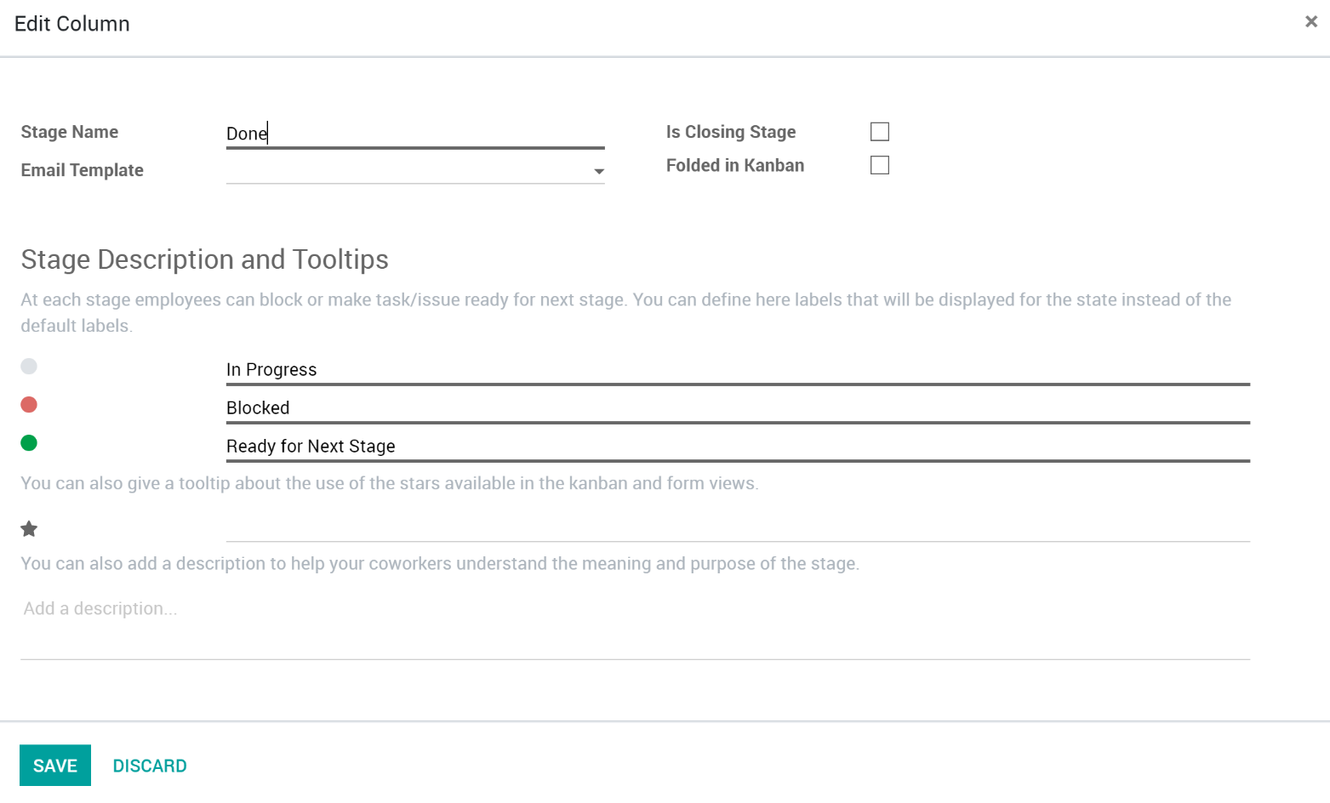

1. Click on **Save** when you are done.

## Rearrange stages

You can easily personalize this view to better suit your business needs by creating new columns. From the Kanban view of your project, you can add stages by clicking on Add new column. If you want to rearrange the order of your stages, you can easily do so by dragging and dropping the column you want to move to the desired location. You can also fold or unfold your stages by using the Setting icon on your desired stage.

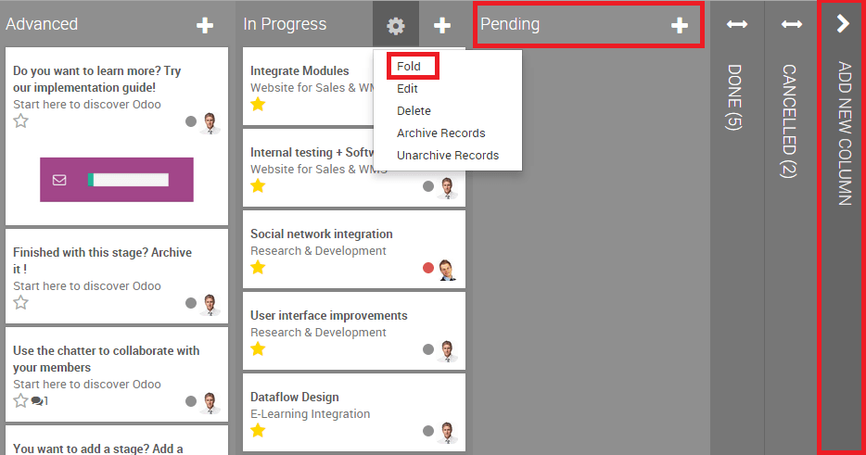

# Creating a Task

## Responsibilities

In Odoo, you can assign the person who oversees the task.

When creating a task, by default you are responsible for it. You can change this by simply typing the username of someone else and choosing it from the suggestions in the drop down menu.

# Followers

In a project or task, you can add other users as Followers. Adding a follower means that this person will be notified of any changes that might happen in the task. The goal is to allow outside contribution from the chatter. This can be invaluable when you need the advice of colleagues from other departments. You could also invite customers to take part in the task. They'll be notified by email of the conversation in the chatter and will be able to take part in it simply by replying to the mail. The followers can see the whole task like you, with the description and the chatter.

## Project: follow a project to follow the pipe

You can decide to follow a Project. In this situation, you'll be notified of any changes from the project: tasks sliding from one stage to another, conversation taking place, etc. You'll receive all the information in your inbox. This feature is perfect for a Project Manager who wants to see the big picture all the time.

## Task: follow a specific task

Following a task is the same idea as following a project, except you are focused on a specific part of the project. All notifications or changes in that task also appear in your inbox.

## Choose which action to follow

You can choose what you want to follow by clicking on the down arrow in the Following button.

By default, you follow the discussions, but you can also choose to be notified when a note is logged in, when a task is created, blocked or ready to go, and when the stage of the task has changed.

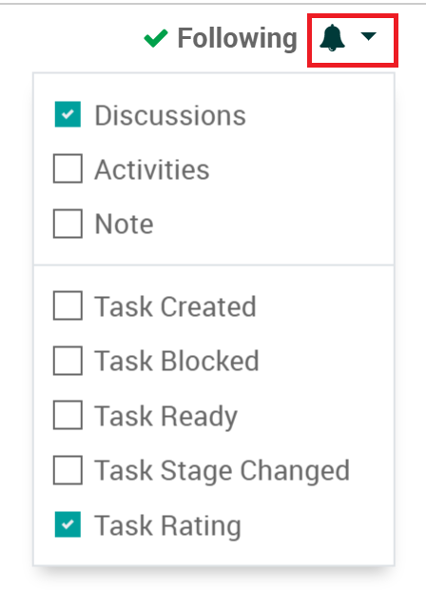

As a Project Manager, you can also specify what notifications each follower gets, click the followers drop down then hover over a follower, and you will see the pencil icon to edit what notifications they will get.

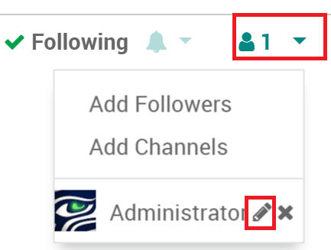

# Auto Forecasting

If Auto Forecasting is enabled for a Project, when a Task gets assigned, has planned hours and a start/end date, a Forecast record is automatically created. If any of those items change, the Forecast record is automatically updated. This helps ease the overhead it takes to manage forecasting.

## Enabling Auto Forecasting

Enabling Auto Forecasting is done on a per Project basis and ‘Allow Forecasting’ needs to be checked in order to see the option.

1. Open a Project in Edit mode.
2. Make sure ‘**Allow Forecasts**’ is checked.
3. Go to the **Settings** Tab.
4. Check the ‘**Allow Auto Forecasts**’.

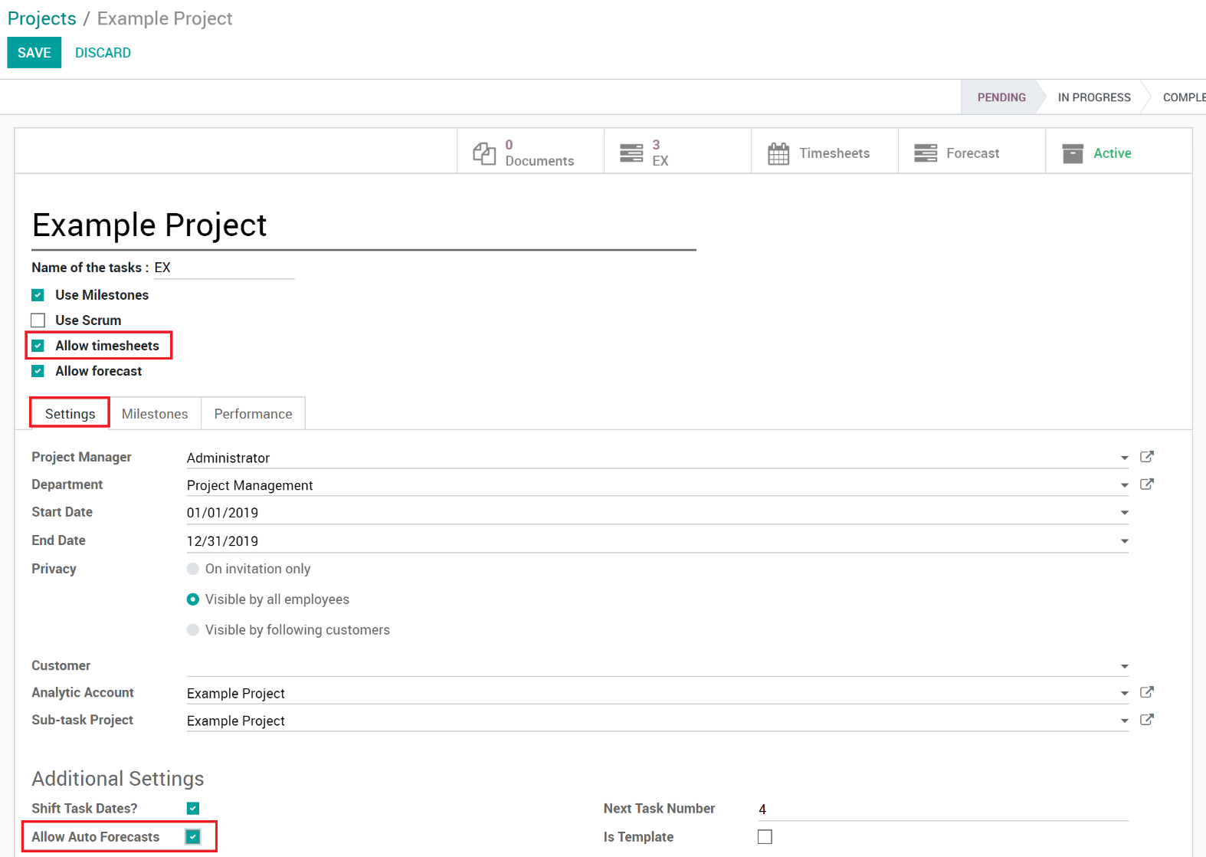

1. Click ‘**Save’** to save your Project.
2. Now when the relevant fields are filled in on a Task, a Forecast will be auto created.

## Viewing Forecasts

### On Projects

1. Open the Project.
2. In the Top Left, if Forecasts exist then you can click the ‘Forecast’ quick link.

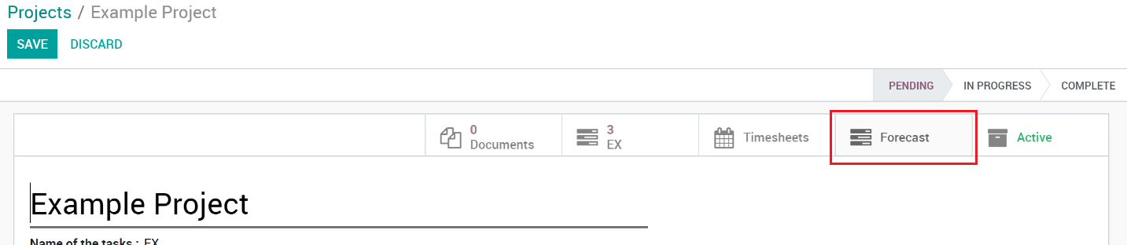

### On Tasks

1. Open the Task.
2. Go to the Forecasts Tab
3. All created Forecasts related to this Task will be listed. If auto create is enabled then they will show as well as any manually created Forecasts.

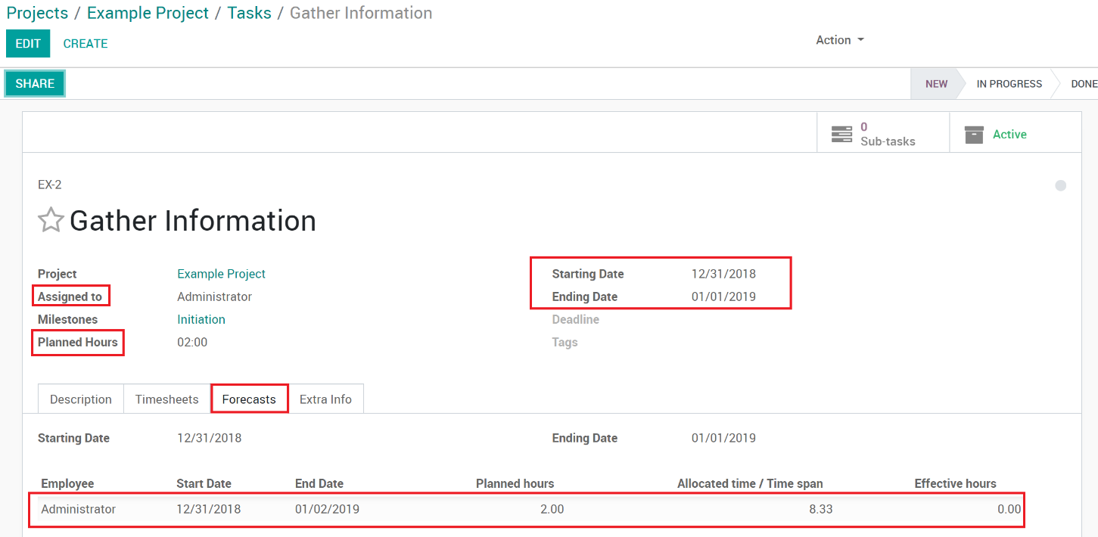

# Milestones

Milestones are used in project management to mark specific points along a project timeline. These points may signal anchors such as a project start and end date, a need for external review or input and budget checks, among others. In many instances, milestones do not impact project duration but allow for Task groupings by Milestones.

## Enabling Milestones on a Project

1. Open the Project in Edit mode.
2. Check the ‘**Use Milestones**’ checkbox.

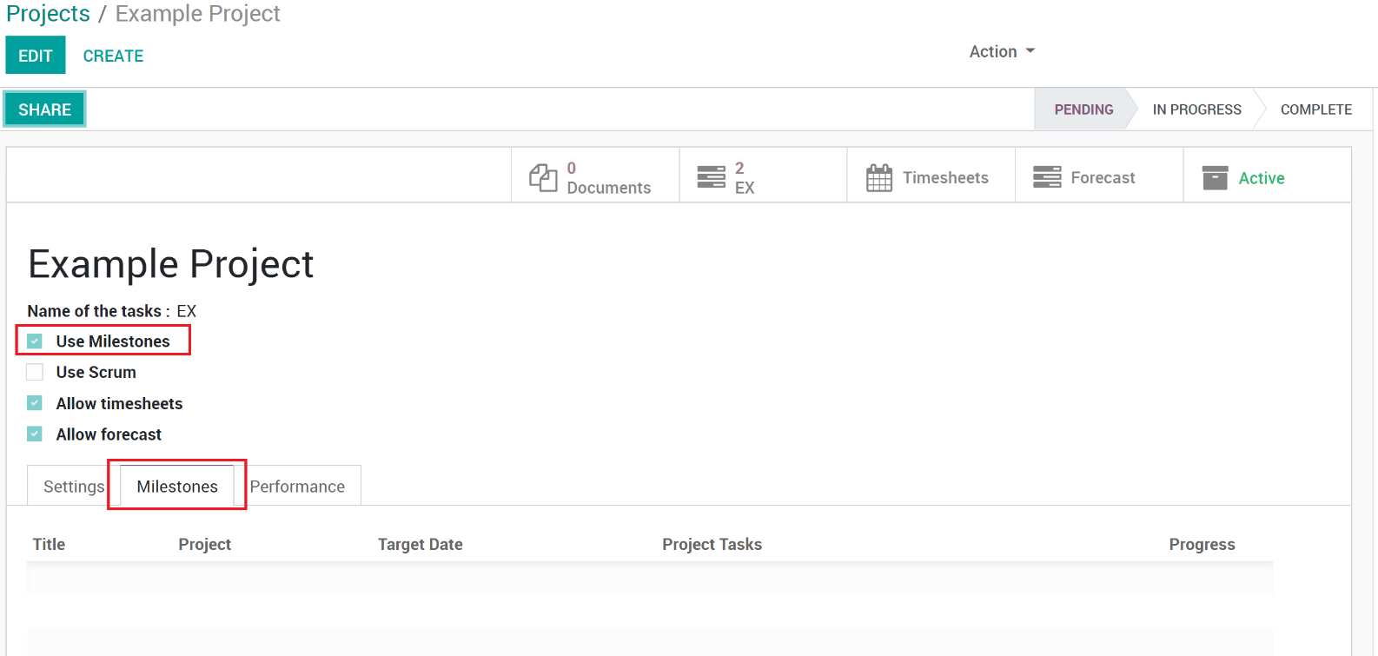

1. Once enabled, the Milestones tab will show where you can manage Milestones on the Project.

## Creating Milestones

1. Open the Project in Edit Mode.
2. Go to the Milestones tab.
3. Create a new Milestone by clicking the ‘Add a line’ link

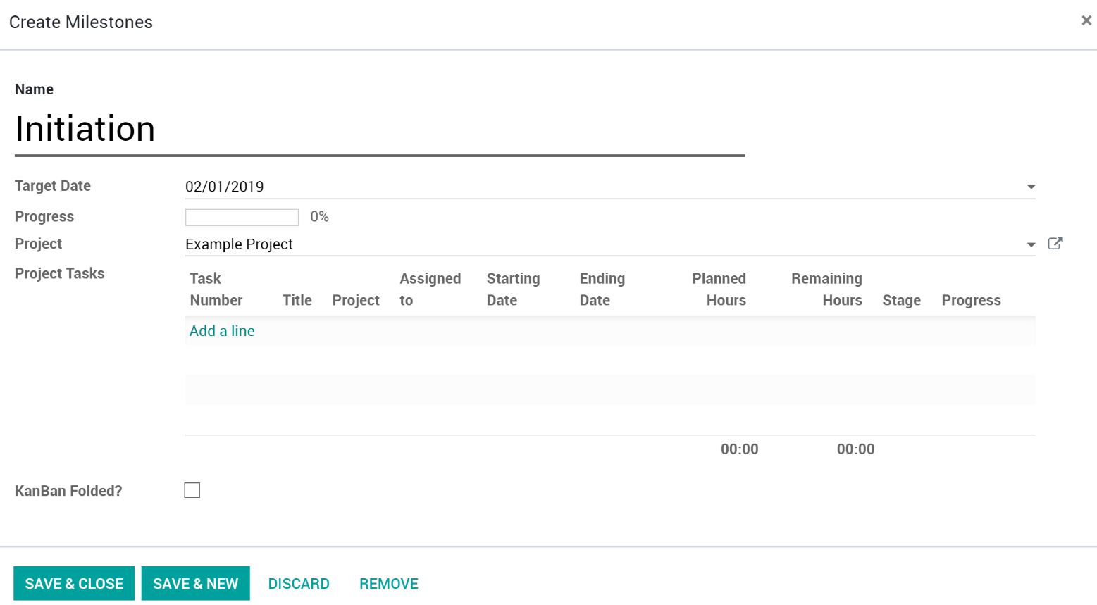

1. Field Descriptions:
   1. **Name**: Name of the Milestone.
   2. **Target Date**: Set the date that all the Tasks within the Milestone are expected to be completed, therefore the Milestone is expected to be completed.
   3. **Project**: Should auto fill with the current Project. Can be changed to another Project too.
   4. **Project Tasks**: List of Tasks that have been set to use this Milestone.
   5. **KanBan Folded?:** Because Milestones can be used to group by on the Task Kanban view, you can set the Milestone to be folded on that view.
2. Click ‘**Save & Close’** if you are done, or ‘**Save & New’** to create another.
3. Click ‘**Save’** on the Project to fully save the changes.
4. While in Edit Mode, you can rearrange the Milestones by drag and drop within the Milestone list. This can also be done while looking at the Tasks and grouping by Milestones. See ‘View by Milestones’
5. Now that Milestones are enabled and created on the Project, you can select them when creating your Tasks.

## View by Milestones

List: You can change the Task List view to group by Milestones. To do so…

1. Open the Tasks for the Project.
2. Switch to the Task List View.
3. Click the ‘Group By’ drop down then select ‘Milestones’.

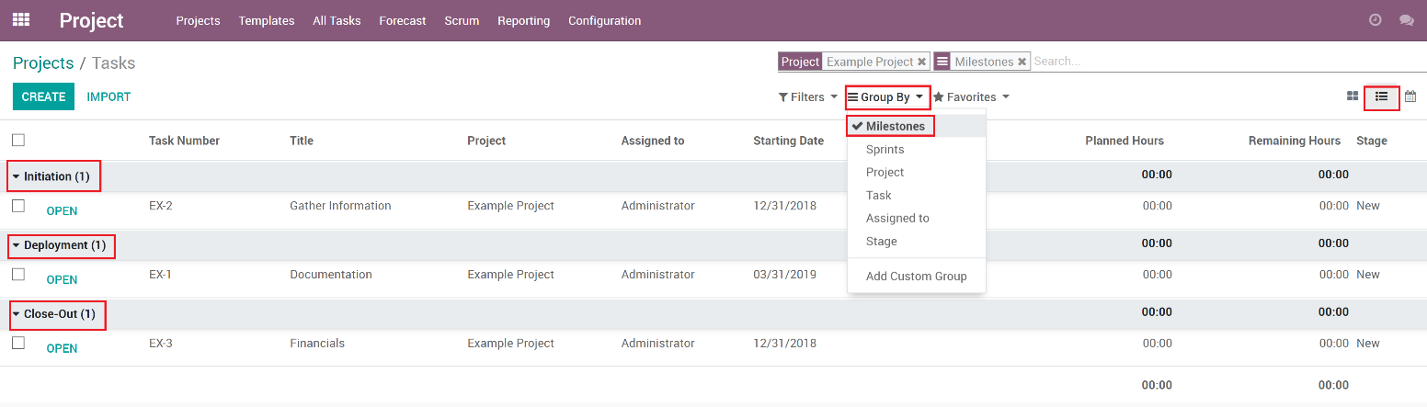

1. You can now see the Tasks listed underneath each Milestone.

Kanban: You can change the Task Kanban view to group by Milestones. To do so…

1. Open the Tasks for the Project.
2. Click the ‘Group By’ drop down then select ‘Milestones’.

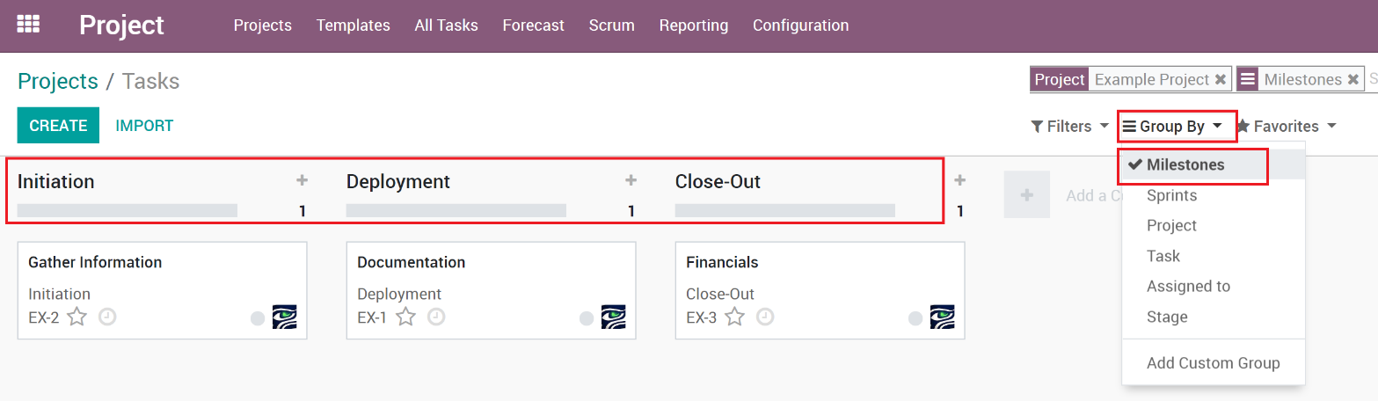

1. You can now see the Tasks listed underneath each Milestone.

# Templates

Templates are created the same way as a Project is, but has a ‘Is Template’ check box to convert the Project to a Template.

## Creating a Project Template

Templates are created the same way as a Project is, but has a ‘Is Template’ check box to convert the Project to a Template.

1. Create a Project.
2. Open the Project in Edit mode
3. Check the ‘**Is Template**’ checkbox. When checked, the name will now show a (TEMPLATE) at the end.

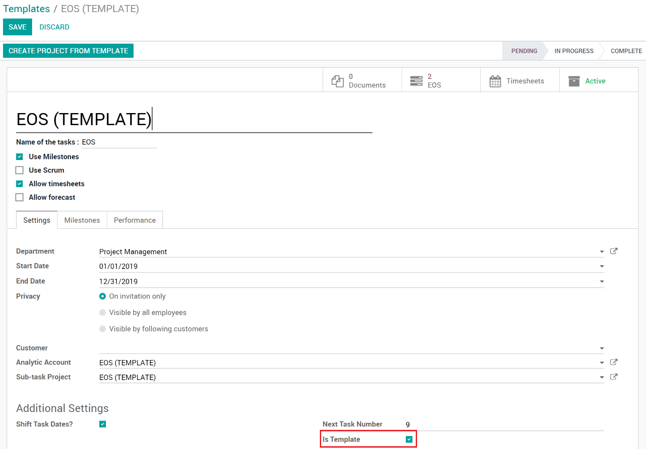

1. Click ‘**Save’** to save the Project.
2. The Project is now considered a Template and will now show in the Templates area and can be used by users to create Projects from.

## Create a new project (from Template)

1. Go to **Templates** in the menu.



1. Find the Template you want to create a Project from and click the ‘**Create Project From Template**’ button.

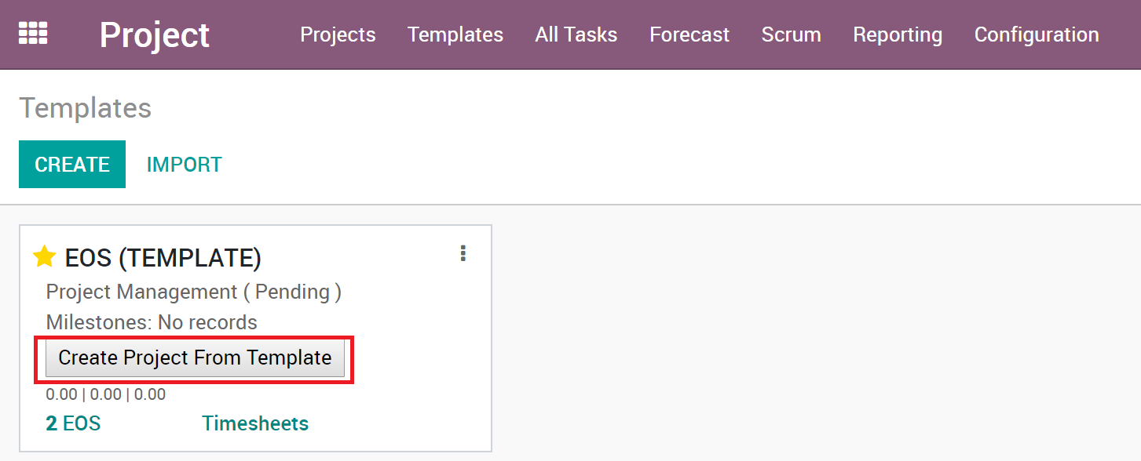

1. Your newly created Project will open, edit and change the information to match your needs.

# Date Shifting

# Scrum